**ReDesign and Topology Optimization for “ROCKER ARM-FSAE-F1”.**

Student's name(s):1) HARSH N. SUKHADIA (210410119014)

2) JASH ILASARIYA (210410119022)

3) PRANAV PATIL (210410119005)

Department of Mechanical engineering last year, SARDAR VALLABHAI PATEL INSTITUTE OF TECHNOLOGY-VASAD.

Supervisor's name: Dr.Chetan Yadav

**Date:-6 Sep. 2024**

**ABSTRACT**

The project focuses on leveraging advanced computational techniques, specifically Redesign and topology optimization, to create efficient and lightweight structural solutions. The main objective is to reduce material usage while maintaining optimal performance, ultimately leading to more sustainable designs. Based on predefined constraints, and topology optimization, which refines these designs by distributing material only where necessary to maximize efficiency. Key results demonstrate a reduction in material usage by up to 6.5% with improved structural integrity and performance compared to traditional design methods. In conclusion, the integration of Redesign and topology optimization proves highly effective, enabling innovative designs that achieve superior material efficiency and performance which is Optimal material TI-5A1AL-2.5Sn titanium alloy.

**Keywords:** [Topology optimization](https://www.mdpi.com/search?q=topology+optimization); [Generative design](https://www.mdpi.com/search?q=generative+design); Cad modelling; FEA.

**INTRODUCTION**

The project focuses on the use of cutting-edge computational design methods, particularly generative design and topology optimization, to create innovative and efficient structural solutions. The primary objective is to reduce material usage while maintaining or enhancing the performance of the structure. Generative design, driven by algorithms, generates multiple design possibilities based on predefined performance criteria such as load-bearing capacity, material constraints, and boundary conditions. Topology optimization complements this by refining the design, ensuring material is used only where it is structurally necessary. Key results demonstrate significant material savings, up to 6.5% while improving structural integrity and creating complex geometries that traditional methods cannot achieve. This approach offers promising applications in industries like aerospace, automotive, and architecture, where material efficiency and performance are critical, pushing the boundaries of conventional design.

**Background on Generative Design and Topology Optimization**

Generative design and topology optimization are transformative techniques in mechanical engineering that leverage advanced computational methods to enhance design efficiency and material use. Generative design involves utilizing algorithms to generate a diverse range of design solutions based on specified constraints and objectives, resulting in innovative and optimized outcomes. Topology optimization, a focused approach within generative design, aims to refine material distribution within a defined design space to achieve optimal structural performance while minimizing weight.

Software tools such as SolidWorks, and specialized topology optimization programs play a crucial role in applying these techniques. offers cloud-based generative design and topology optimization capabilities, SolidWorks provides robust simulation tools for performance analysis, and dedicated topology software focuses on material efficiency and structural integrity.

#### Problem Statement

The project aims to reduce the mass and manufacturing costs of a rocker arm by using Cad modelling, FEA analysis, generative design concept and topology optimization concept through, SolidWorks, and specialized topology software. The goal is to optimize material distribution while maintaining structural integrity, resulting in a lighter, cost-efficient rocker arm design.

**Objectives and Scope of the Project**

Objective:

The objective of this project is to reduce the mass and manufacturing costs of a rocker arm by utilizing CAD modelling , FEA concept, generative design and topology optimization techniques in, SolidWorks, and specialized software. The aim is to achieve a lighter, structurally sound design with optimized material usage.

Scope:

The project will focus on applying computational tools to explore design alternatives for the rocker arm, reducing material usage while maintaining performance. It will cover design iteration, analysis, and validation using generative design and topology optimization to achieve cost and weight reduction goals.

**Relevance to Mechanical Engineering and Design Optimization**

The project is highly relevant to mechanical engineering and design optimization as it addresses key challenges in component design, such as mass reduction and cost efficiency, critical for improving performance and sustainability. By using advanced tools like, SolidWorks, and specialized software for generative design and topology optimization, the project demonstrates modern approaches to optimizing mechanical components like the rocker arm. This leads to lighter, more efficient designs that reduce material waste and production costs, directly benefiting industries focused on performance, energy efficiency, and resource management.

**NOMENCLATURE**

**Definitions of Terms, Symbols, and Abbreviations**

**Generative Design (GD)**  
Definition: A computational design method that uses algorithms to explore a wide range of design alternatives based on specified goals and constraints.

**Topology Optimization (TO)**  
Definition: A mathematical approach to optimizing the distribution of material within a design space to achieve the best structural performance while minimizing material usage.

**Rocker Arm**  
Definition: A mechanical component used in internal combustion engines that converts rotational motion into linear motion.

**Mass Reduction (MR)**  
Definition: The process of decreasing the weight of a mechanical component through design modifications, often to enhance performance and reduce costs.

**SolidWorks**  
Definition: A 3D CAD software developed by AssaultSystems used for modelling, simulation, and optimization of mechanical components.

**Specialized Topology Software (STS)**  
Definition: Software specifically designed for performing topology optimization, which may include tools like Altair OptiStruct or ANSYS Topology Optimization.

**Design Space (DS)**  
Definition: The defined volume or boundary within which topology optimization algorithms operate to determine optimal material distribution.

**Objective Function (OF)**  
Definition: A mathematical function that defines the goals of the optimization process, such as minimizing weight or maximizing strength.

**Constraints (C)**  
Definition: Conditions or limitations imposed on the design, such as maximum allowable stress, displacement limits, or manufacturing constraints.

**Load Conditions (LC)**  
Definition: External forces or moments applied to the component that influence the design optimization process.

**Manufacturing Constraints (MC)**  
Definition: Limitations related to the manufacturing process that impact the design, such as fabrication methods or material availability.

**Cost Efficiency (CE)**  
Definition: The measure of reducing production costs while maintaining or improving the performance and quality of the component.

**Optimization Iterations (OI)**  
Definition: The repeated cycles of design adjustments and evaluations during the optimization process to converge on the best design solution.

**Feasibility Study (FS)**  
Definition: An assessment to determine whether the optimized design can be practically manufactured and implemented.

**Simulation Results (SR)**  
Definition: Outcomes from the analysis of the design under simulated conditions to validate its performance and effectiveness.

**LITRATURE REVIEW**

#### Review of Existing Methods and Applications of Generative Design and Topology Optimization

Generative design and topology optimization have become integral to modern mechanical engineering, significantly enhancing design efficiency and material utilization. Existing methods for these techniques have been extensively applied across various industries. Generative design utilizes algorithms to generate multiple design alternatives based on specified constraints, goals, and parameters. Notable applications include lightweight aerospace components, complex automotive parts, and optimized consumer products. Tools such as have popularized generative design by offering cloud-based solutions that facilitate rapid exploration of design possibilities and real-time performance evaluation.

Topology optimization, on the other hand, focuses on material distribution within a predefined design space. Techniques such as density-based methods, evolutionary algorithms, and level-set methods are employed to achieve optimal structural performance while minimizing weight. Applications are widespread, ranging from optimizing structural components in civil engineering to improving the mechanical efficiency of automotive and aerospace parts.

#### Analysis of State-of-the-Art Techniques

Recent advancements in generative design and topology optimization have introduced several state-of-the-art techniques:

**Hybrid Methods:** Combining topology optimization with generative design algorithms to create more refined and efficient solutions. These methods integrate multi-objective optimization to balance performance and manufacturability.

**Cloud-Based Tools:** Software like leverages cloud computing to perform extensive design iterations and simulations quickly, enabling designers to handle complex optimization tasks efficiently.

**Additive Manufacturing Integration:** Modern topology optimization techniques are increasingly aligned with additive manufacturing technologies, allowing for the creation of complex geometries that were previously difficult or impossible to fabricate.

**Advanced Simulation Capabilities:** Enhanced simulation tools in platforms like SolidWorks provide more accurate predictions of real-world performance, improving the reliability of optimization results.

**Multi-Scale Optimization:** Techniques that consider various scales—from microstructural to macrostructural levels—to optimize the performance and durability of materials and components.

#### Identification of Gaps and Opportunities in Current Research

Despite significant advancements, several gaps and opportunities remain in the research and application of generative design and topology optimization:

**Integration Challenges:**While tools like SolidWorks offer powerful optimization features, integrating these tools with other specialized software for seamless workflows remains a challenge. Research into more cohesive multi-tool integration could enhance efficiency.

**Manufacturability Issues:** Although generative design and topology optimization can create highly efficient designs, translating these designs into manufactural components can be problematic. There is a need for more research into optimizing designs for practical manufacturing processes.

**Material Constraints:** Current methods often assume ideal material properties, but real-world materials may exhibit variability that affects performance. Research into incorporating material property variations into optimization processes could improve the applicability of designs.

**Cost Analysis:** While mass reduction is a primary focus, comprehensive cost analysis, including manufacturing and lifecycle costs, is less frequently addressed. Opportunities exist to develop methods that better balance performance improvements with cost reductions.

**User Accessibility:** Advanced optimization techniques can be complex and require specialized knowledge. Simplifying these methods and making them more accessible to a broader range of engineers and designers could enhance their adoption and effectiveness

**Methodology**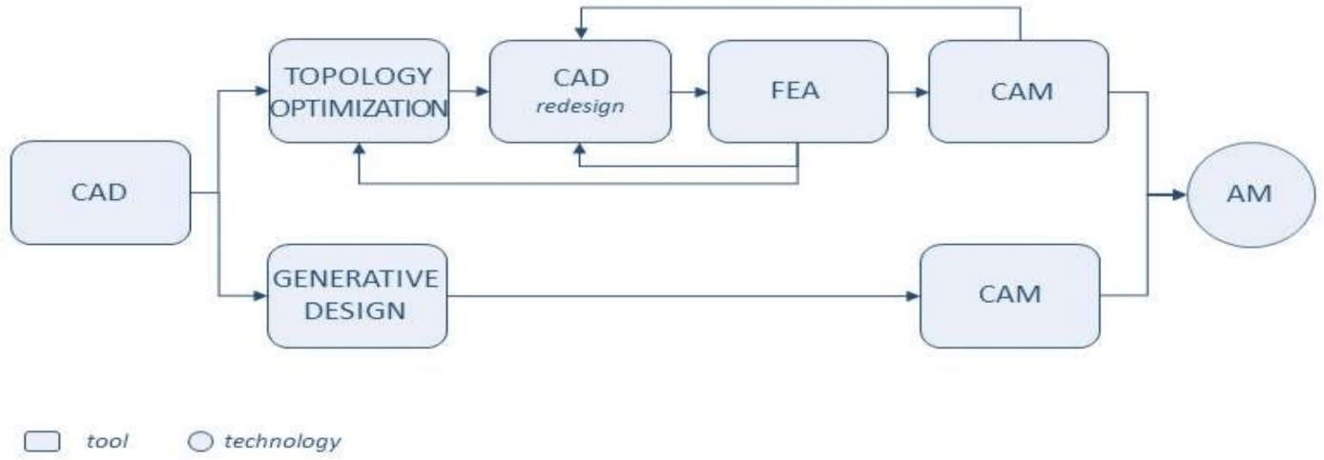

The methodology for this project entails a detailed process of optimizing a rocker arm design using generative design and topology analysis, specifically focusing on titanium as the material and applying a force of 1200 MPa. The project begins with the creation of a precise 3D model of the rocker arm in SolidWorks. This model includes all critical geometric features and dimensions necessary for subsequent analysis. Once the initial design is established, it is imported into, which facilitates the application of generative design techniques. In, the design objectives and constraints are set, including the requirement to minimize mass while ensuring the structural integrity of the rocker arm under a load of 1200 MPa. The generative design tools in then explore a wide range of design alternatives, producing multiple optimized configurations based on these parameters.

The optimized designs from are then transferred to specialized topology optimization software, such as ntopology. Here, the focus shifts to refining the material distribution within the rocker arm, using titanium’s properties and applying the same force constraint of 1200 MPa. The topology optimization process further refines the design by optimizing the placement of material to balance strength and efficiency, while removing unnecessary material from less critical areas.

Following the optimization, the designs are imported back into SolidWorks for a thorough performance evaluation. Finite element analysis (FEA) is conducted to simulate the effects of the 1200 MPa force on the optimized designs. This analysis assesses various factors, including stress, strain, and deformation, to ensure that the redesigned rocker arm can withstand the applied forces and meet all design requirements.

Once the most promising design is selected based on the simulation results, it undergoes refinement to enhance manufacturability and practical application. The refined design is then prepared for prototyping, taking into account the specifics of titanium as the material. A prototype is produced using appropriate manufacturing techniques and subjected to rigorous testing to validate its performance under the specified load conditions.

Throughout the project, detailed documentation is maintained to capture the methodologies employed, design iterations, optimization processes, and performance evaluations. A comprehensive final report is prepared, summarizing the project’s outcomes, including design improvements and recommendations for production and implementation. This systematic approach ensures that the rocker arm is effectively optimized using generative design and topology analysis techniques, with a focus on performance under significant loading conditions and the use of titanium as the material.

**RESULTS**

Table 1:- “FEM” ANALYSIS TABLE

1) BUCKLING ANALYSIS

|  |  |  |  |  |
| --- | --- | --- | --- | --- |
| Sr. No. | Boundary Condition | Deflection | Figure | Percentage of reducing deflection. |
| 1 | -Larger circle is fixed (Internally)  -smallest circle get force of 650N  -Middle circle get forces internally of 1200N,  -Material = Titanium Ti-5Al-2.5Sn | 0.20 |  | 4.76% |
| 2 | -Larger circle is fixed (Internally)  -smallest circle get force of 650N  -Middle circle get forces internally of 1200N,  -Material = Titanium Ti-5Al-2.5Sn | 0.18 |  | 14.28% |
| 3 | -Larger circle is fixed (Internally)  -smallest circle get force of 650N  -Middle circle get forces internally of 1200N,  -Material = Titanium Ti-5Al-2.5Sn | 0.17 |  | 19.04% |
| 4 | -Larger circle is fixed (Internally)  -smallest circle get force of 650N  -Middle circle get forces internally of 1200N,  -Material = Titanium Ti-5Al-2.5Sn | 0.16 |  | 23.8% |

2) STATIC ANALYSIS

|  |  |  |
| --- | --- | --- |
|  |  |  |
|  |  |  |
|  |  |  |
|  |  |  |
|  |  |  |
|  |  |  |
|  |  |  |

|  |
| --- |
|  |

|  |  |  |  |  |  |  |  |  |  |
| --- | --- | --- | --- | --- | --- | --- | --- | --- | --- |
| |  |  |  | | --- | --- | --- | |  |  |  | |  |  |  | |  |  |  | |

|  |  |  |  |
| --- | --- | --- | --- |
| Sr.NO. | Static Analysis | Boundary Condition | Figure |
| 1 | Stress | -Larger circle is fixed (Internally)  -smallest circle get force of 650N  -Middle circle get forces internally of 1200N,  -Material = Titanium Ti-5Al-2.5Sn |  |
| 2 | Displacement | -Larger circle is fixed (Internally)  -smallest circle get force of 650N  -Middle circle get forces internally of 1200N,  -Material = Titanium Ti-5Al-2.5Sn |  |
| 3 | Strain | -Larger circle is fixed (Internally)  -smallest circle get force of 650N  -Middle circle get forces internally of 1200N,  -Material = Titanium Ti-5Al-2.5Sn |  |

Top of FormBottom of Form**Flow chart of the optimum design of rocker arm FSEA part**

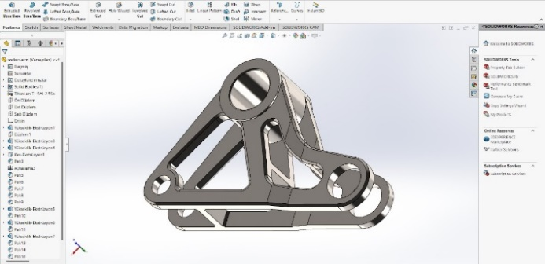

1. **Initial CAD model design with 182 g**

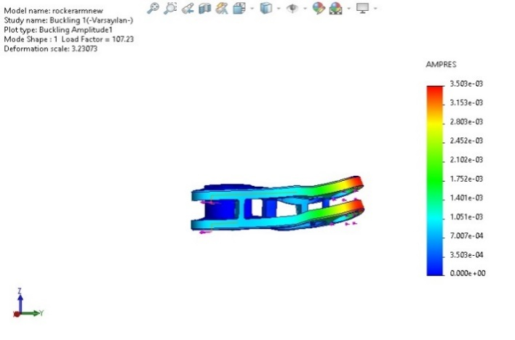

1. **FEM buckling analysisoptimal solution with 23.8% accuracy**

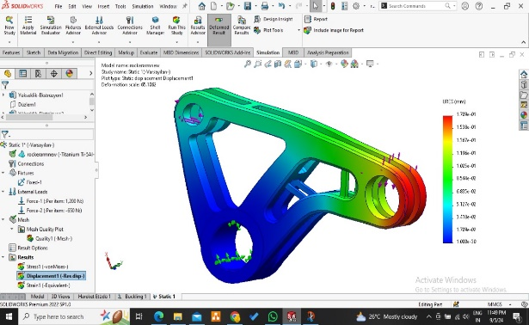

**3.Optimal displacement static analysis**

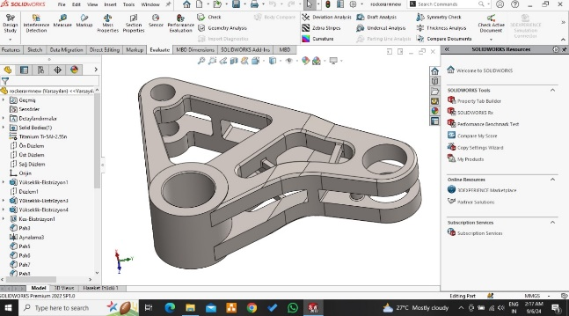

**4.CAD final model design with 257.60g**

**TOPOLOGY ANALYSIS FLOW CHART**

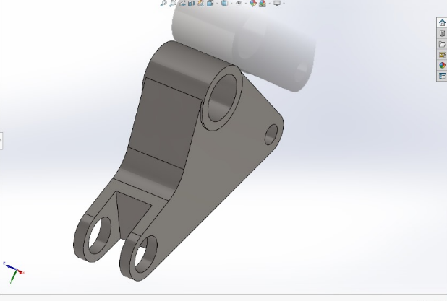

**5. CAD MODEL-417g**

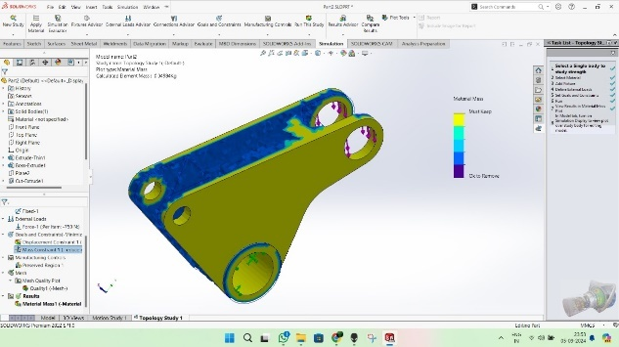

**6. Topology model 1 with 70% reduction of initial weight becomes 124g**

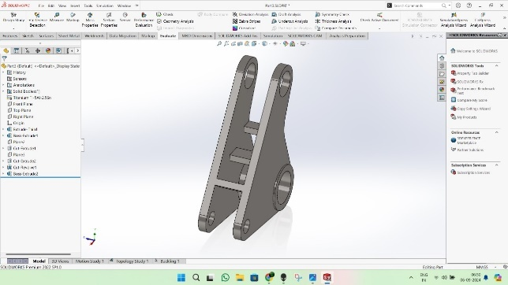

**7. CAD-Redesign weight 204g**

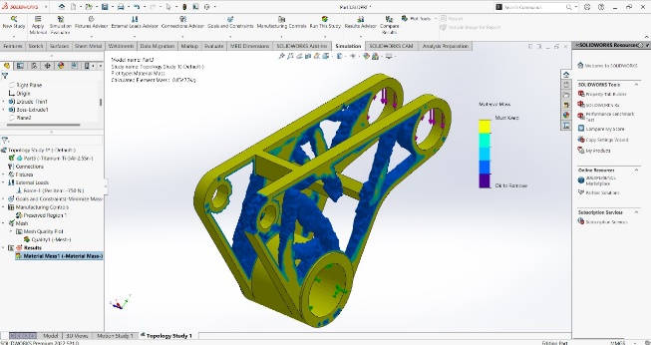

**8. Topology model 2 with 30% of “7 drawing” weight becomes 142.8g**

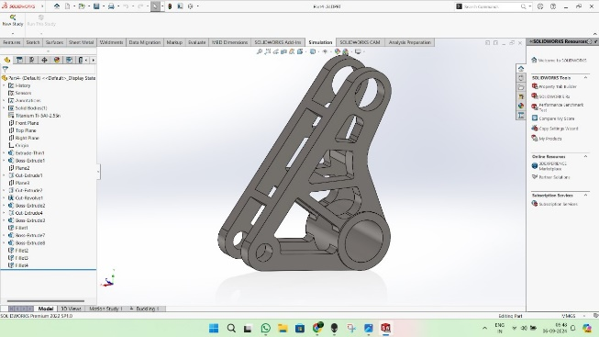

**9. Final optimal solution weight 170.14g**

**Table of comparisons study:-**

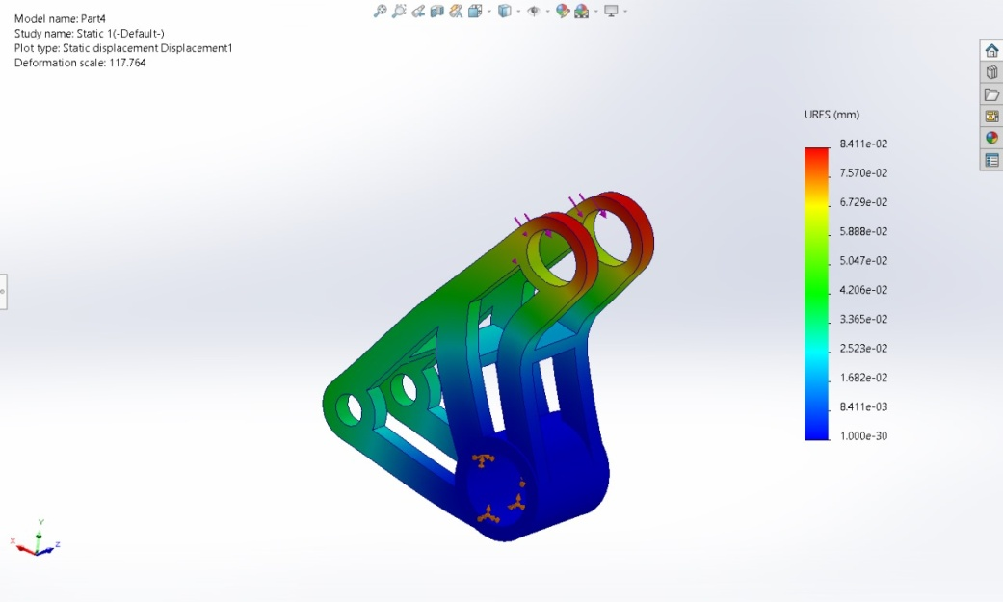

**Buckling result**

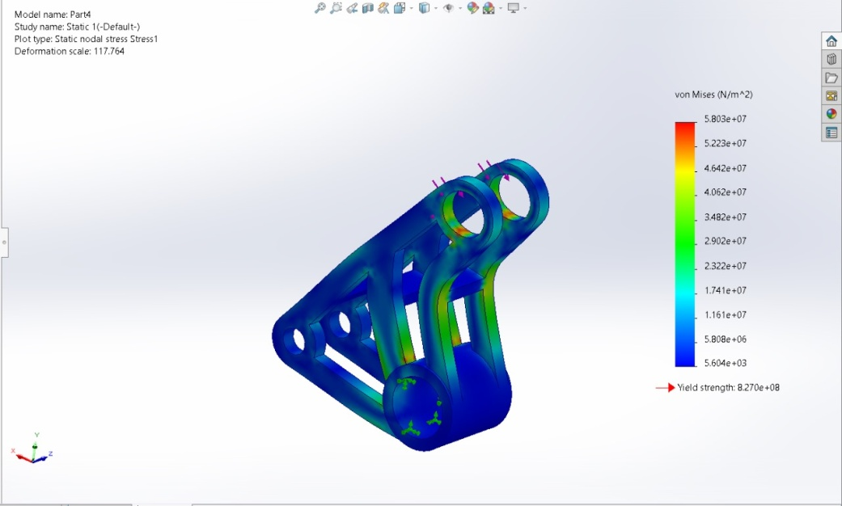

**Static result**

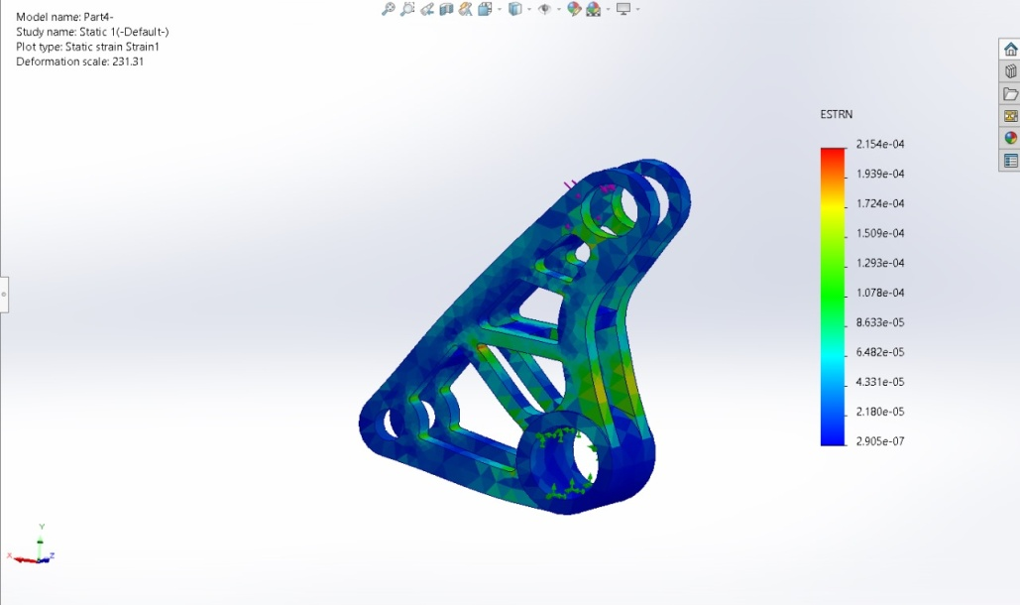

**Static result**

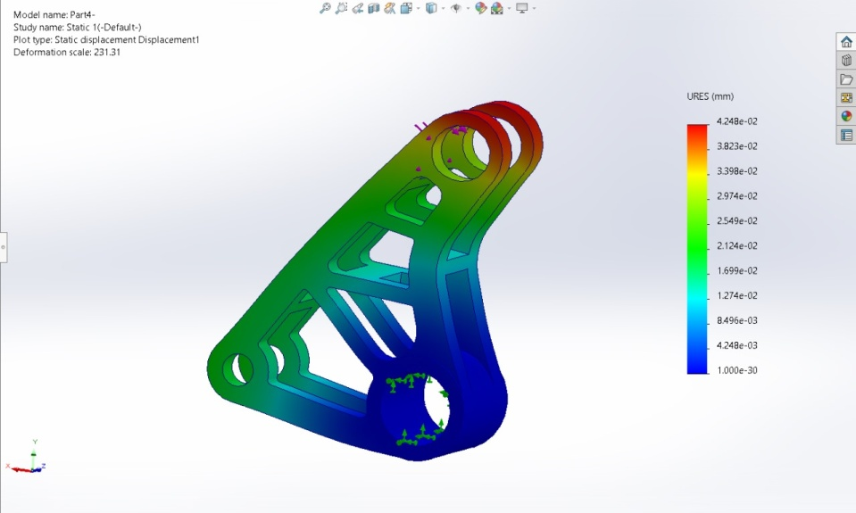

**Buckling result**

**Material selection:-**

In the highly demanding world of Formula 1, the choice of materials for critical components like rocker arms in the suspension system is crucial.Ergal Titanium Alloy stands out as a superior option compared to other materials, such as steel or aluminium, due to its unique combination of properties. Ergal Titanium is renowned for its exceptional strength-to-weight ratio, which is particularly valuable in F1 where reducing weight while maintaining strength is essential for optimal performance and handling. It has a density of about 4.5 g/cm³, significantly lighter than steel and only slightly heavier than aluminium, but its tensile strength is comparable to that of steel, making it robust enough to endure the extreme stresses encountered during high-speed racing. Additionally, titanium exhibits excellent fatigue resistance and corrosion resistance, which is crucial given the harsh operating conditions in F1, including high temperatures and exposure to various chemicals. For example, using titanium for rocker arms allows teams to achieve a lightweight, durable, and reliable suspension component, contributing to improved vehicle dynamics and overall performance on the track.(Reference No. 1,3,4)

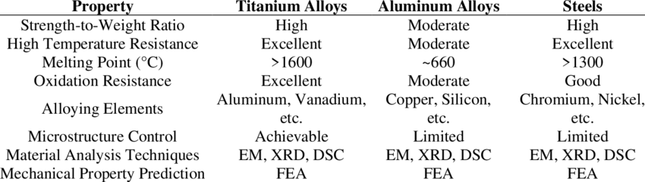

**WHY “TI-5A1AL-2.5SN” IS USED?**

**TI-5Al-2.5Sn, a titanium alloy with 5% aluminium and 2.5% tin, is a prime choice for rocker arms in F1 car suspensions due to its exceptional blend of properties**. This alloy offers an excellent balance of strength, weight, and durability, which is critical in high-performance racing applications. With a high tensile strength of around 1,200 MPa and a density of just 4.43 g/cm³, TI-5Al-2.5Sn is significantly lighter than steel while providing superior strength compared to other titanium alloys, such as pure titanium or Grade 2 titanium. Its strength-to-weight ratio is crucial for reducing unsprang mass, thereby enhancing vehicle handling and responsiveness. Additionally, this alloy provides good fatigue resistance, which is essential for withstanding the cyclic loads experienced during racing, and excellent corrosion resistance, ensuring longevity and reliability under harsh conditions. For instance, using TI-5Al-2.5Sn in rocker arms helps F1 teams achieve a robust yet lightweight component, optimizing suspension performance and contributing to overall vehicle agility and speed on the track.(REFERENCE NO. 4)

**RESULTS**

**Table-2:**

|  |  |  |  |
| --- | --- | --- | --- |
| **Design** | **Volume** | **Percentage reduction from the initial design** | **Final Optimal weight** |
| **Original(from reference 1)** | **57500 mm^3** | **-** | **182g** |
| **Topology Optimization** | **37946.4 mm^3** | **Trial 1)-70%**  **Trial 2)-30%** | **Trial 1)-204g**  **Trial 2)-170.14g** |
| **Generative design** | **-** | **-** |  |

**Flow chart of optimal cad model**

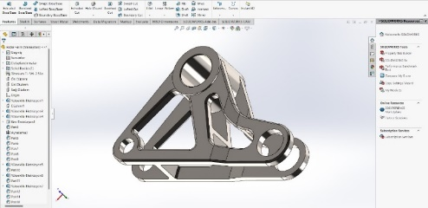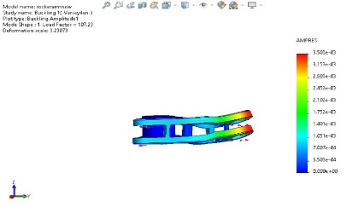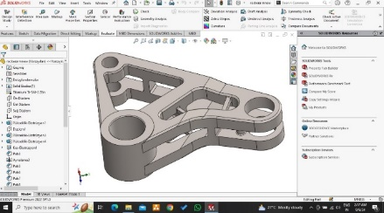

**Original CAD model FEA of CAD model, Optimal 3D CAD**

**180g from research tends to23% after model 257.60g**

**paper three analysis**

**Flow chart of topology analysis**

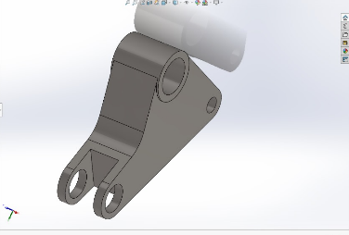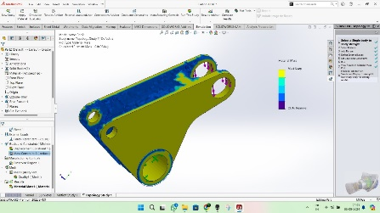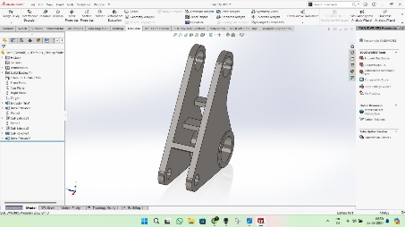

**1)Initial Weight 417g 2) TO trial 1 70% of mass reduction 3)Redesign model weight 204g**

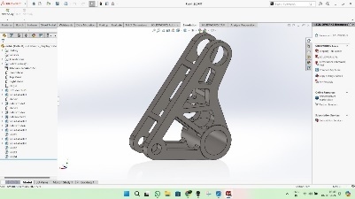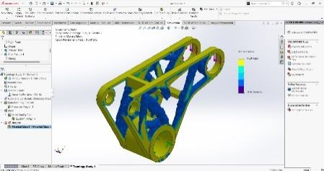

**5)Optimal Final solution weight 170.14g 4)TO Trial 2 30% of mas reduction**

**FINAL RESULTS**

|  |  |  |
| --- | --- | --- |
| **ORIGINAL RESEARCH PAPER (2)** | **OUR SOLUTIONS** | **OPTIMAL RESULTS** |
| **WEIGHT 182g** | **WEIGHT 170.14g** | **6.5% improvement** |
| **MATERIAL –ERGAL TITANIUM** | **MATERIAL-TITANIUM-TI-5A1AL-2.5SN** | **TITANIUM-TI-5A1AL-2.5SN** |

**REFRENCES**

**1: Performance-Driven Engineering Design Approaches Based on Generative Design and Topology Optimization Tools: A Comparative Study**[**https://doi.org/10.3390/app12042106**](https://doi.org/10.3390/app12042106)

**2**:**DESIGN AND ANALYSIS OF ROCKER ARM**

**file:///C:/Users/admin/AppData/Local/Microsoft/Windows/INetCache/IE/6KZZMRYS/Design_and_analsyis_of_rocker_arm_(dimensions)[1].pdf**

**3:Mechanical Properties of Materials: Definition, Testing and**

**ApplicationLink :** **file:///C:/Users/admin/AppData/Local/Microsoft/Windows/INetCache/IE/IKF9ELK7/3[1].pdf**

**4:Properties and applications of titanium alloys: A brief review**[**https://www.researchgate.net/publication/283863116_Properties_and_applications_of_titanium_alloys_A_brief_review**](https://www.researchgate.net/publication/283863116_Properties_and_applications_of_titanium_alloys_A_brief_review)

**5:Design and optimization of suspension for formula Society of Automotive Engineers (FSAE) vehicle**[**https://doi.org/10.1016/j.matpr.2020.07.077**](https://doi.org/10.1016/j.matpr.2020.07.077)

# **6:Generative Design and Topology Optimisation of Products for Additive Manufacturing**

[**https://www.researchgate.net/publication/365329780_Generative_Design_and_Topology_Optimisation_of_Products_for_Additive_Manufacturing**](https://www.researchgate.net/publication/365329780_Generative_Design_and_Topology_Optimisation_of_Products_for_Additive_Manufacturing)